HTML – Basic Course / code with harry

We are learning it in vs code.

Where by entering ! I can get the boiler plate of html code.

Index.html ??

The default or main HTML file that acts as the foundation for a website is referred to as "index.html" in web development. For web development, "index" denotes the primary landing page or home page of a website. A website's index or home page connects users to various areas of the site, the same as a book's table of contents does for different chapters.

Note : HTML is use for designing the layout of website, building the architecture or structure.

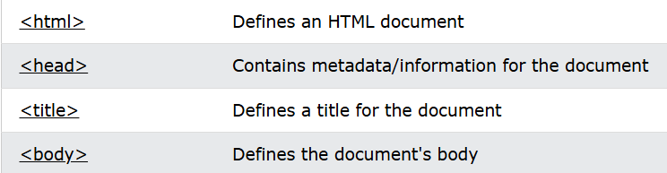

<!DOCTYPE html>

<html lang="en">

<head>

    <meta charset="UTF-8">

    <meta name="viewport" content="width=device-width, initial-scale=1.0">

    <title>Document</title>

</head>

<body>

</body>

</html>

Syntax will look like this

Where every tags include opening and closing for example :

<html> : opening tag </html> : closing tag

There are some of self closing tags which don’t require closing tag. such as **<img>**and **<br>.**

Use comment ;

Highlight the area you want to transform into comment.

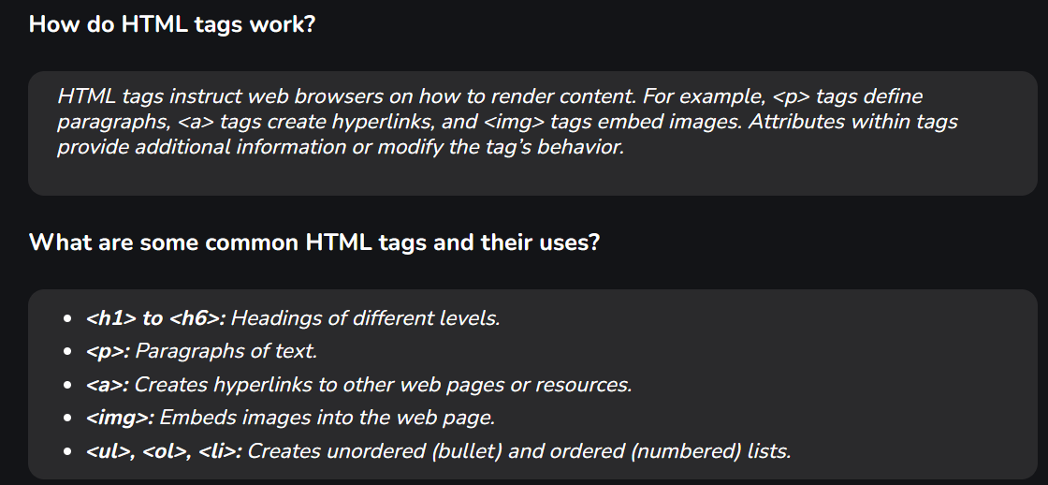Ctrl + / ( forward slash )

HTML is not case sensitive.

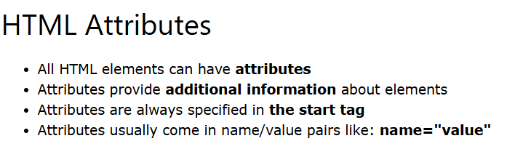Body tag is the visible portion of website.

Some of the attributes are :

**1. href Attribute**

**2. src Attribute**

**3. Width and Height Attributes**

**4. alt Attribute**

**5. style Attribute**

**6. lang Attribute**

**7. Title Attribute**

<a> .. </a> - anchor tag is used to add links to an existing content inside an html page.

<h1> .. </h1> - heading tag, it can be up to 6

<p> .. </p> - paragraph tag

<img> - image tag use to display image having attributes scr, alt, height , width, etc…

|  |  |
| --- | --- |
| [<b>](https://www.w3schools.com/tags/tag_b.asp) | Defines bold text |
| [<br>](https://www.w3schools.com/tags/tag_br.asp) | Defines a single line break |

Scr – source, alt – name of image

<big> : make words bigger in size

<small> : make words smaller in size

<sub> : allow word to be in sub script form

<sup> : allow word to be in super script form

<pre> ; allow text shown as spaces done in writing

<hr> : separate line shown

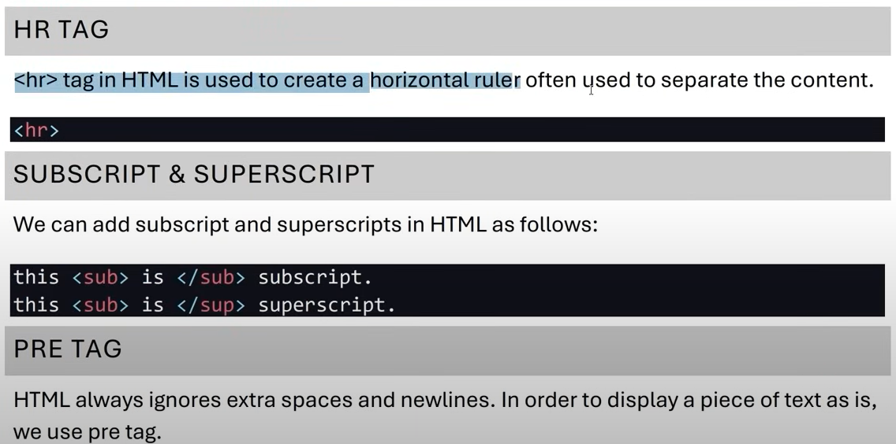

Note : type img and enter for img tage auto facilitate with source and alt.

# Website layout :

<header>

<main>

<footer>

Website layout which helps for google ranking.

<header> tag contain <nav> tag indicate for navigation bar

We work further on main tag, including various tags such as <div>, <article>, <section>,<aside>, etc..

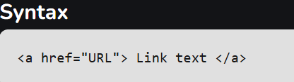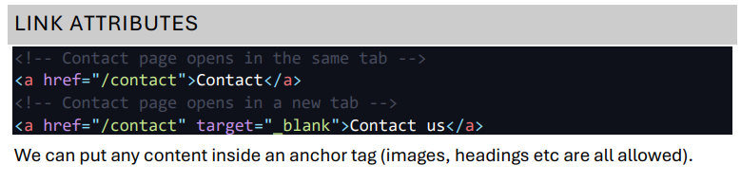<nav> - use for navigation bar in header section.

The <a> tag defines a hyperlink, which is used to link from one page to another.

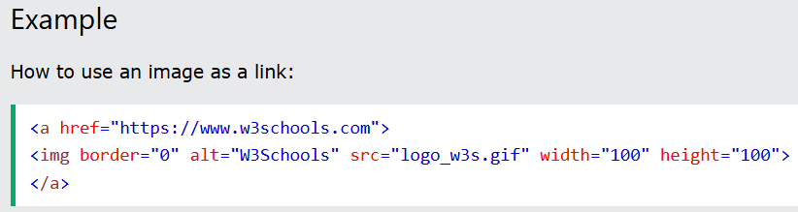

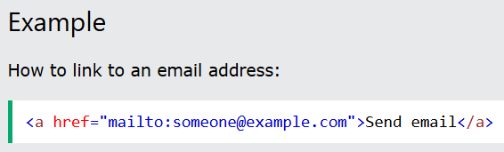

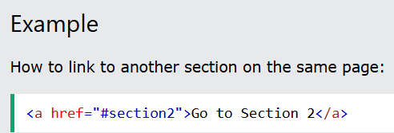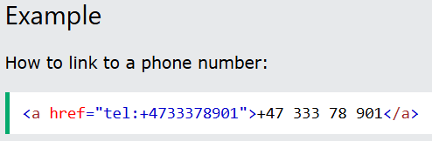

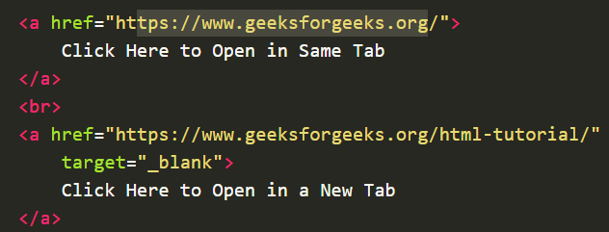

If the page is inside a directory, we need to make sure that we link to the correct page (Same applies to img tag as well.)

External pages inside same folder or same directory :

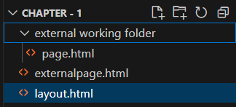

As you can see I am working in layout.html , where externalpage.html is link for another section , and page.html is too. But here is slight difference that externalpage.html and layout.html are inside same working directory ,but page.html is inside different folder name “external working folder” in that case we should set proper file path location .

But we can also link from different drive location too.

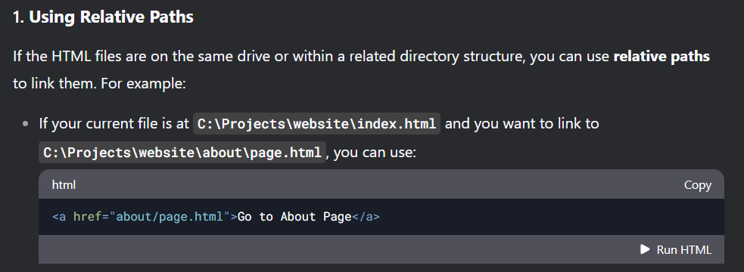

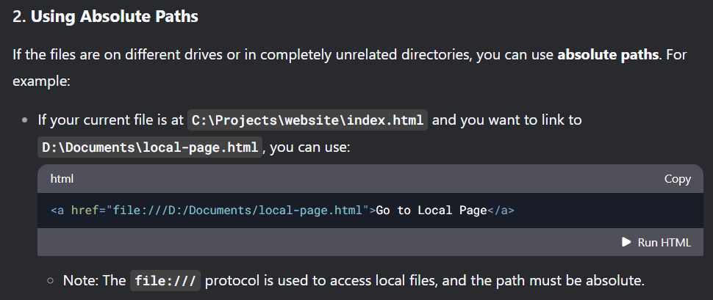

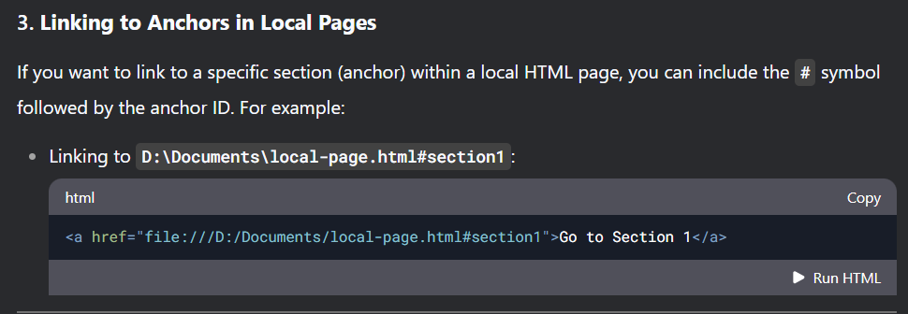

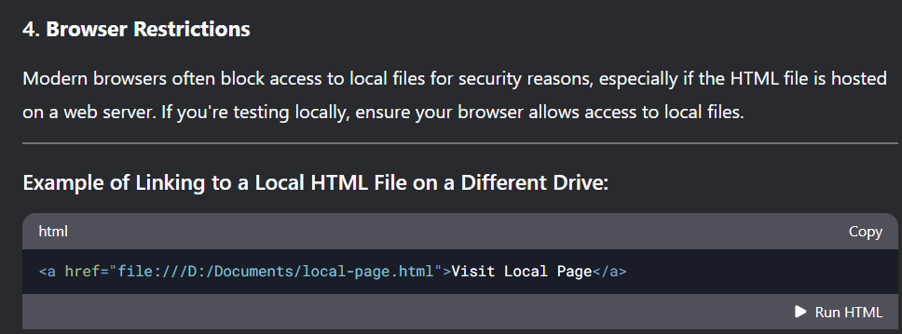

Integrate file, exe url which is locally available in our storage.

<a href = “application_name.exe”> Download application </a>

<div> tag

It takes full 100% width space

<span> tag

It takes only necessary width want for content

Here you’ll find diffference :

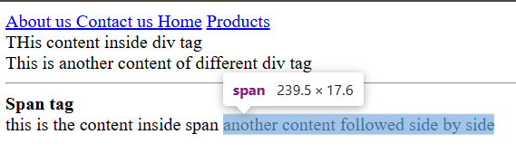

Very much essential for like every website building procedure :

<header> </header>

<main> </main>

<footer> </footer>

Lists , Tables and forms :

List include ordered list, unordered list, definition list.

Ordered list tag : <ol>

<li> .. </li>

<li> .. </li>

</ol>

Unordered list tag : <ul>

<li> .. </li>

<li> .. </li>

</ul>

Definition list tag:

<dt>Python </dt>

<dd> Python is a high-level, interpreted programming language known for its simplicity, readability, and versatility. It supports multiple programming paradigms, including procedural, object-oriented, and functional programming. </dd>

dt means data term , dd ie; data definition.

Tables in html :

<table>

<thead>

<tr>

<th>SN</th>

<th>Name</th>

<th>Salary</th>

<th>Age</th>

<th>Address</th>

<th>Gender</th>

</tr>

</thead>

<tbody>

<tr>

<td> 1 </td>

<td>Sandesh</td>

<td>500000</td>

<td>19</td>

<td>Kathmandu</td>

<td>Male</td>

</tr>

</tbody>

<table> tag : is the main structure tag where I will create rows accordingly.

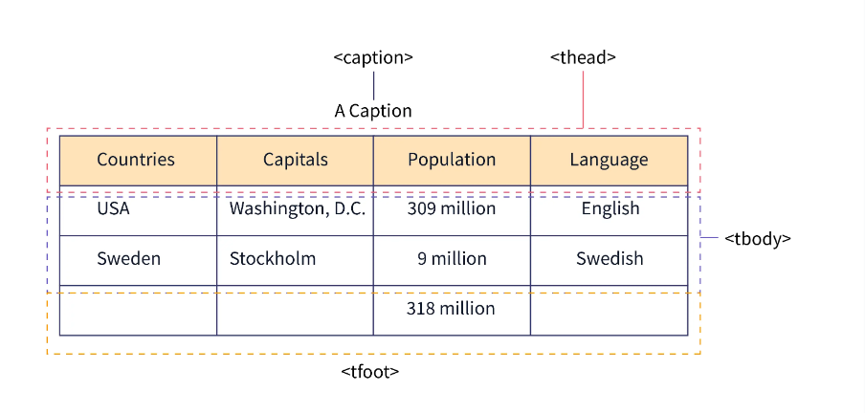<thead> tag : is another tag which is basically the field of table for example :

Header consider ; countries, capitals, population , language, name, age etc. of the table and remaining other rows contain the data or information.

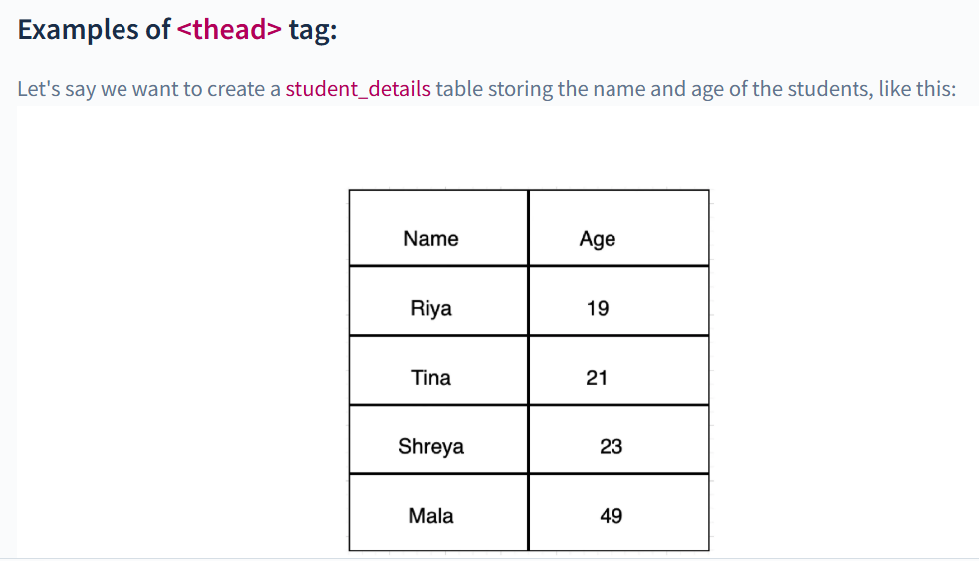

In HTML, colspan and rowspan are attributes used in table cells (<td> or <th>) to merge cells across multiple columns or rows.

**1. colspan (Column Span)**

* The colspan attribute allows a cell to span across multiple columns.
* It effectively merges cells horizontally across multiple columns in a table.

**Syntax:**

<td colspan="number">Content</td>

Example :

<table border="1">

<tr><th>Header 1</th>

<th>Header 2</th>

<th>Header 3</th>

</tr> <tr>

<td colspan="2">Merged across 2 columns</td>

<td>Cell 3</td> </tr></table>

**2. rowspan (Row Span)**

* The rowspan attribute allows a cell to span across multiple rows.
* It effectively merges cells vertically down multiple rows in a table.

**Syntax:**

<td rowspan="number">Content</td>

Example : <table border="1"> <tr>

<th>Header 1</th>

<th>Header 2</th>

<th>Header 3</th> </tr>

<tr><td rowspan="2">Merged across 2 rows</td>

<td>Cell 2</td>

<td>Cell 3</td> </tr>

<tr><td>Cell 4</td>

<td>Cell 5</td> </tr> </table>

